Talking Points on Why You Should Attend
Attending the ORTESOL Annual Fall Conference is valuable for learning, networking and staying motivated as you work in the field of TESOL.
Here are some talking points to help you get the approval you need.
- The ORTESOL Annual Fall Conference is one of the few local conferences focused exclusively on English language teaching and learning.
- There is a wide variety of session types that focus on everything from K-12, Refugee Concerns, Adult Education and Higher Education. You can learn about the latest research in the field, current best practices, and even pick up a lesson plan or two.
- You can receive a certificate with PDUs (professional development units). This argument is especially powerful if you are required to complete a certain number of continuing education hours per year.
- You will have numerous opportunities to network with colleagues, connecting you to a broad range of experience and expertise in every aspect of English language teaching and learning. Networking also re-energizes you, and you can bring that energy back to the workplace.
- The knowledge and training that you will gain is a return on the investment. You can also share your new knowledge and training with your colleagues. This way, everyone in your workplace can benefit from your attendance.
- In addition to sharing with your colleagues, you could communicate what you learned or are researching with other ESOL professionals around the state:
  - You could write a blog for the ORTESOL newsletter about your favorite experiences at the conference.
  - If you presented you could even extend your topic by submitting an article to the ORTESOL Journal.
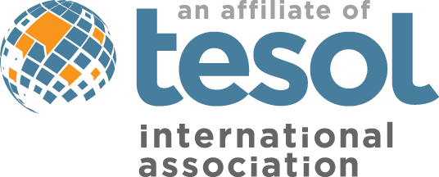
- The exhibitor area has as the latest books and educational products from TESOL publishers and other companies. This is a great way to get personalized advice on choosing the best curriculum for your students. This is also a great area to network as you meet with different company representatives.
Find us online at
ortesol.org

