The Impact of Wiki-based Collaborative Writing on English L2 Learners’ Individual Writing Development
Gina Caruso (gccaruso@gmail.com)& Domminick McParland
Portland English Language Academy
Purpose
- Investigate how to use technology tools to develop L2 learners’ English writing ability
- Investigate whether the benefits of collaborative writing can be transferred to the individual

Motivation
- Students are already using technology to mediate communication and socialize so why not use this type of interaction to facilitate written language development?

Research Questions
- Does collaborative writing in a wiki space influence the individual writing of intermediate and advanced level English L2 learners on measures of linguistic complexity, accuracy, and fluency? If so, how, and to what extent are these measures affected?
- How do learners in the study perceive wiki-based collaborative writing activities?

Overall Design
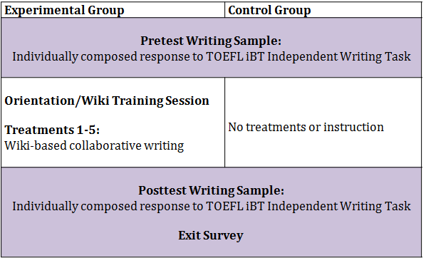

Methodology
Participants (N=12)
  - Intermediate/advanced English L2 learners
  - University students, Spanish L1
  - Treatment group (n=8), control group (n=4)
Task Design
  - TOEFL iBT Independent Writing Task
- Read a prompt and express your opinion, preference, or choice
- Support with reasons and examples based on personal experience or knowledge
  - 30 minutes allotted

Instruments & Analysis Procedures
Performance Data (pre/posttests)
- Quantitative analysis
- 15 dependent measures (linguistic complexity, accuracy & fluency)
- Between group comparison with Mann-Whitney U test
- Within group comparison with Wilcoxon test

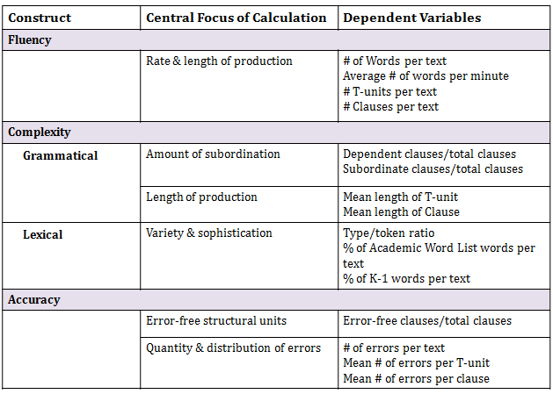

Perception Data (exit survey using Google Form)
- Quantitative analysis (Likert scale rankings)
- Qualitative analysis (open-response questions)

Summary of Results for Research Question 1
- Overall mixed results
- Promising gain scores for treatment group on fluency measures
- Inconsistencies observed in complexity and accuracy measures
- Notable performance of control group participants from pre to posttest

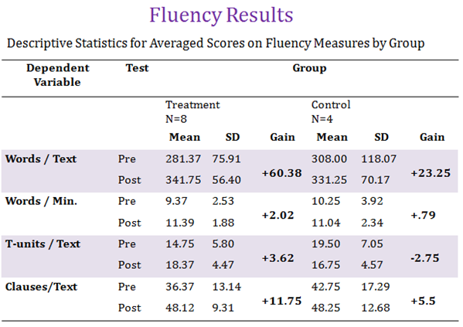

Summary of Results for Research Question 2
- Learners reported having an overall positive experience with wiki-based collaborative writing (ease of use, educational, writing with a partner easier than writing alone)
- Perceived improvements in grammar and vocabulary
- Asynchronous nature of the wiki is a drawback
- Absence of auto-save function is frustrating
Conclusions
- Wiki-based collaborative writing seems to have a positive impact on individual writers’ fluency
- Collaborative writing in a wiki did not provide much positive support for an increase in individuals’ written complexity or accuracy
- Wiki-based collaborative writing was enjoyable and educational for learners
- Use of web technology has the potential to expand L2 writers’ linguistic experiences

Limitations
Overall Design
  - Small convenience sample
  - Inconsistent attendance of treatment group participants
  - Outside instruction influenced results
  - Relatively short treatment period
  - Somewhat inauthentic use of wiki technology
Analysis Measures (complexity, accuracy, fluency)
  - Unable to cover the full trajectory of L2 development
  - Some measures not sensitive enough to capture delicate differences
Pedagogical Implications
- Longer collaborative writing sessions may be advantageous
- Wiki-based collaborative writing activities might be beneficial to promote written fluency
- In-class scaffolding/training session is necessary
- Collaborative writing in a wiki might be best used outside of class for extended assignments while a synchronous tool like Google Docs might be more appropriate for timed, in-class work
- Some individuals might just learn better when working alone

Future Research Directions
- Larger scale investigations which examine the long-term impacts of collaborative writing on individual writing performance
- Use of a reliable computational tool to automate measures of linguistic complexity
- Narrow focus to more specific measurements of linguistic features
- Examine additional data (wiki-discussion board interactions, textual revisions) to determine whether individual learners can appropriate and internalize linguistic structures used by their peers during the collaborative writing process

Educational Applications of Wikis
- Post class information
- Share resources
- Whole class/group projects
- Brainstorming
- Reflection/feedback/discussion
- Peer or teacher writing review
- Showcase student work for an audience

Specific Classroom Use Ideas for Various Levels and Contexts
- Create alphabet books
- Create a spelling wiki that becomes a virtual word wall
- For a grammar lesson, students edit a paragraph inserting punctuation, capitalization, verb forms, etc.
- Build a story by having each student add a sentence to an existing storyline
- Global pen pal project-students connect with peers in classrooms around the world

Recommended Wiki Platforms
PB Works http://www.pbworks.com/education.html
Wiki Spaces https://www.wikispaces.com/
Wikis in Education http://wikisineducation.wikifoundry.com/
Compare Wiki Services http://www.wikimatrix.org/

